Lomus Hona
AI: Project 1

- Describe how you generated the permutations representing the tours.
→ I used the method described in https://www.youtube.com/watch?v=GuTPwotSdYw&t=550s to brute force all the permutations using recursive method. So given the task to find permutation of a set {A, B, C }, the given image below is sample of how it works:
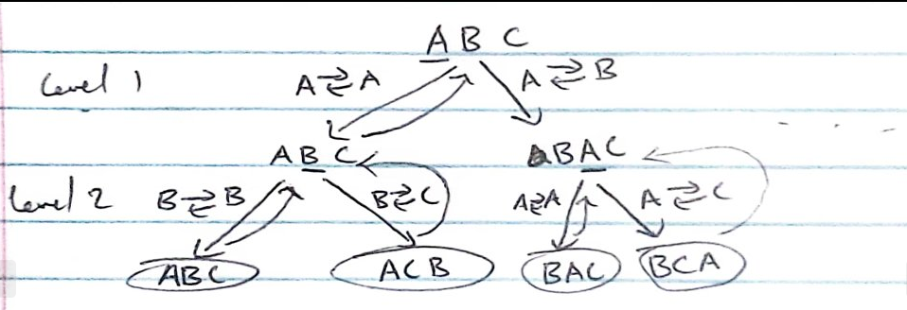
so, given we have {A,B,C}, I initially pick value on 0th index ‘A’ then swap it with 0th index ‘A’ on “level 1” which will result in {A,B,C}. Now I will pick 1st index ‘B’ on result of swapping on “level 1”, and swap 1st index ‘B’ with itself on “level 2”, which results in {A,B,C}. Then after “level 2” swapping I pick 2nd index ‘C’ realize it’s a last index and reset {A,B,C} back to its form before “level 2” swapping, which means we will have {A,B,C} which resulted after “level 1” swapping. And since we swapped 1st index with 1st index, now we swap 1st index ‘B’ with 2nd index ‘C’ on “level 2” swapping which will produce result of {A,C,B}. And then we again track back to {A,B,C} resulted after “level 1” swapping, realize that there is no more index or strings to swap and go backtrack to original state {A,B,C} before level 1 swapping. From here since we swapped 0th index with 0th index, we now swap 0th index with 1st index which results in {B,A,C} and do the same thing that we did previously for {A,B,C} that resulted after “level 1” swapping which will produce {B,A,C} and {B,C,A}. All possible permutation of set {A,B,C} using the recursive method is shown below:
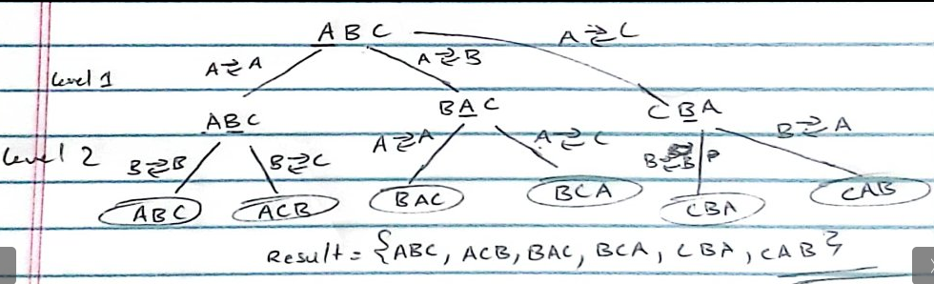

- Show the route and the cost of the optimal tour for each provided dataset.
→ I got multiple path that share the lowest value for all but 2 of the files, therefore listed them all.
Random4.tsp
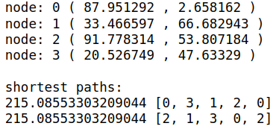

Random5.tsp
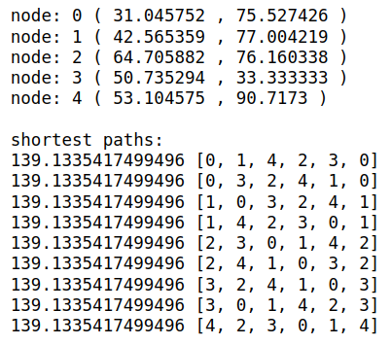

Random6.tsp
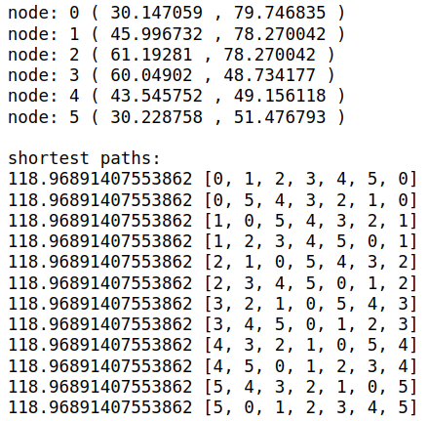

Random7.tsp
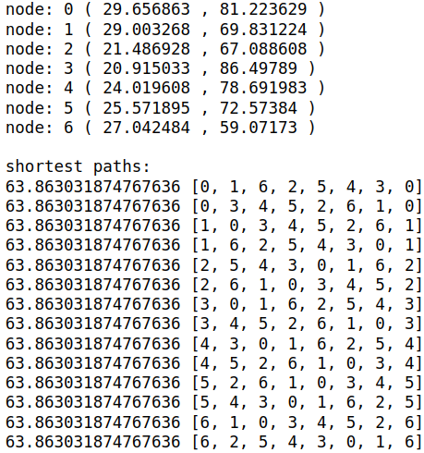

Random8.tsp
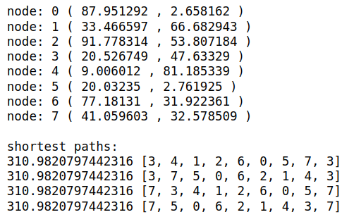

Random9.tsp
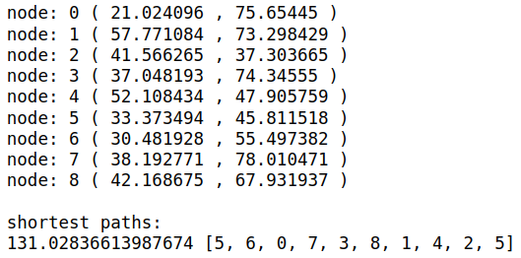

Random10.tsp
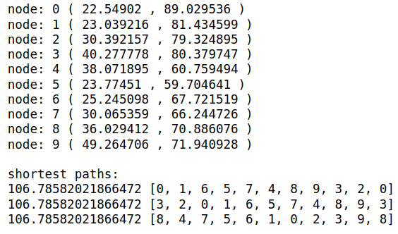

Random11.tsp
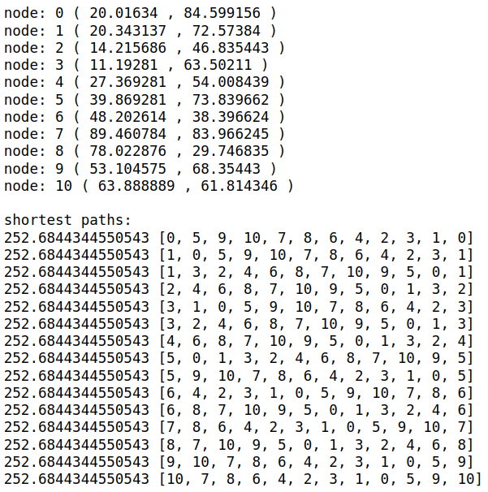

Random12.tspv
It gave me a “Kernel died error” on anaconda, which on stack overflow mentioned is caused when computer runs out of space in RAM


